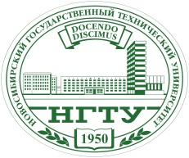 | 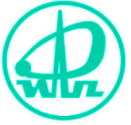 | 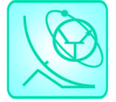 | 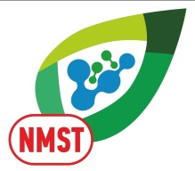

FIRST ANNUAL RUSSIAN NATIONAL CONFERENCE ON NANOTECHNOLOGIES, NANOMATERIALS
AND MICRO/NANOSYSTEMS TECHNOLOGIES

Novosibirsk State Technical University

PRELIMINARY PRORGAM
1ST Annual Russian National Conference on Nanotechnologies, Nanomaterials and Micro/Nanosystems Technologies
NMST-2016

June 27

8.00 –9.00 Arrival of participants.

9.00 Departure from the 4th building of the NSTU.

12.00 Arrival in the Sedova Zaimka Rest
House.

12.00 – 13.30 Accommodation of participants.

13.30 – 14.30 Lunch.

15.00 – 19.00 Registration of participants.
Sport events.

19.00 – 20.00 Dinner.

20.00 – 22.00 Cultural program.

June 28

9.00 – 9.40 Breakfast.

10.00 – 10.15 Opening ceremony.

10.15 – 11.35 Overview lectures of the Distinguished Lecturers.

11.35 – 11.50 Coffee break.

11.50 – 13.10 Overview lectures of the Distinguished Lecturers.

13.30 – 14.30 Lunch.

Hall A
15.00 – 16.20 Section 1. «Nanotechnologies». Meeting 1. Chairman – Dr. Sc. Vladimir A. Haisler, ISP SB RAS, Novosibirsk.

16.20 – 16.35 Coffee break.

16.35 – 18.15 Section 3. «Micro- and Nanosystems Technologies». Meeting 1. Chairman – Dr. Sc. Prof. Viktor A. Gridchin, NSTU, Novosibirsk.

Hall B
15.00 – 16.20 Section 2. «Nanomaterials». Meeting 1. Chairman – Dr. Sc. Prof. Vladimir A.Bataev, NSTU, Novosibirsk.

16.20 – 16.35 Coffee break.

16.35 – 18.40 Section 2. «Nanomaterials». Meeting 2. Chairman – Dr. Sc. Prof. Vladimir A.Bataev, NSTU, Novosibirsk.

19.30 – 20.30 Dinner.

21.00 Cultural program.

June 29

9.00 – 10.40 Breakfast.

Hall A
10.00 – 11.40 Section 3. «Micro- and Nanosystems Technologies». Meeting 2. Chairman – Dr. Sc. Prof. Viktor A. Gridchin, NSTU, Novosibirsk.

11.40 – 11.55 Coffee break.

11.55 – 13.15 Section 3. «Micro- and Nanosystems Technologies». Meeting 3. Chairman – Dr. Sc. Prof. Viktor A. Gridchin, NSTU, Novosibirsk.

Hall B
10.00 – 11.40 Section 2. «Nanomaterials». Meeting 3. Chairman – Dr. Sc. Prof. Vladimir A.Bataev, NSTU, Novosibirsk.

11.40 – 11.55 Coffee break.

11.55 – 13.15 Section 1. «Nanotechnologies». Meeting 2. Chairman – Dr. Sc. Vladimir A. Haisler, ISP SB RAS, Novosibirsk.

13.30 – 14.30 Lunch.

Hall A
15.00 – 16.20 Section 3. «Micro- and Nanosystems Technologies». Meeting 4. Chairman – Dr. Sc. Prof. Viktor A. Gridchin, NSTU, Novosibirsk.

Hall B
15.00 – 16.20 Section 1. «Nanotechnologies». Meeting 3. Chairman – Dr. Sc. Vladimir A. Haisler, ISP SB RAS, Novosibirsk.

18.40 – 19.10 Final meeting of the Organization
Committee.

20.00 – 21.00 Award Presentation Ceremony to
the best speakers. Banquet.
Firework.

21.30 – 23.00 Cultural program.

June 30

9.00 – 9.40 Breakfast.

10.00 – 12.00 Assembly of participants.

12.00 Departure for Novosibirsk.

15.00 Arrival in Novosibirsk.

